Shakespeare’s Macbeth

Doom. Impending doom. What happens when a man is told his fate? Will he change his behavior? What decisions will he make? Will his hubris be his end? Or will it be his ambitious wife? Through a study of Shakespeare’s Macbeth, you will explore universal themes and understandings. Culminating in a small group performance of a seminal scene, you will live the words of Shakespeare’s Macbeth. In addition to acting and staging in a collaborative group, you will rehearse skills necessary to close read challenging texts, create arguments for or against the existence of free will and develop an understanding of subtext.

Essential Questions: (well, some of them!)
- How do the decisions and actions of people reveal their personalities?
- How can a person’s decisions and actions change his/her life?
- What moves do readers make to help them access Shakespearean text?
- What role, if any, does fate have on our lives?

Outcomes and Evidence:
During Reading- Discern and Argue
Act I: Subtext Art (due Monday 3/24)
Act II: Character analysis entry on goodreads (3/27)
Act III: Theme exploration entry on goodreads (3/31)
After reading: Performance notebook and performance

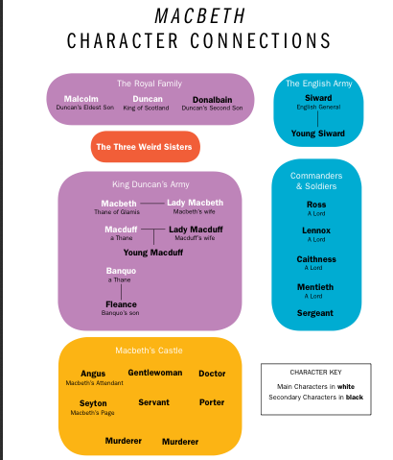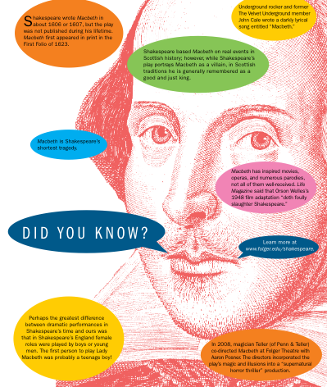

Macbeth Performance Project: Begins March 31st
“Fair is foul and foul is fair”

Shakespeare wrote his plays to be performed, so it’s time to breathe subtext to life.
As a group, you will:
1.edit the script
2. design costumes
3. design the set, music, stage directions and props
4. analyze characters
5. perform for your class

Individually you will:
1. Complete and hand in a Performance Notebook

It’s time for you to join with a small group of your classmates and dig in to one scene. With your groups, please select a scene.

- It is ok if two groups chose the same scene, but no more than two may perform the same scene.
- Memorizing lines is encouraged but not required
- Your performance will be graded according to the attached rubric

In this packet, you will find…
- Performance Notebook Assignment
- Daily Agenda

PERFORMANCE NOTEBOOK
Your notebook will record insights about the delivery of lines, costuming, characterization, staging, music and set and prop choices. This may be messy, as it’s a work in progress- but it should be complete and readable! What it looks like is up to you.

Required Contents of the Notebook
1. Script: Start by reading your scene aloud. Next, copy your scene and cut, trim, and paste each page onto a larger piece of plain paper. (As we did for our promptbooks earlier). CROSS out any lines you intend to cut. This is a group decision and shouldn’t take away from the scene’s meaning. Leave room in the margins and note how the scene will be played. Include:
- Definitions of words and phrases you don’t understand
- Vocal pauses, stress and inflection
- Tone of voice
- Gestures and facial expressions
- Actions or movements

2. Costumes: design two costumes: (1) the conceptual costume (The one you would wear if money were no object), and(2) the actual costume (the one you will improvise for this performance. You may draw these, construct them from magazine cuttings, or simply write out a detailed description explaining your choices (styles, materials, colors, etc.) but tell about both your conceptual and actual costumes (DIRECTORS: you should have a description of each costume)

- Character Analysis: Write an analysis for each character who appears in the scene. As you prepare these analyses, question yourself about the characters’ subtext and motivations in this passage or scene. Also consider what you know about the character up to the point in the play. The following questions should help guide you:
  - What does each character want? What is their motivation?
  - Is there any other SUBTEXT for each character in this scene?
  - Do the characters’ objectives change in this scene? If so, when and why? Do tactics change? If so, how and why? What obstacles stand in each characters way? What happens when objectives meet obstacles?
  - What is distinctive about the way the characters speak (For example, who uses plain language? Elaborate language? Puns Riddles? Sarcasm? Why do you think the character speaks this way?)
- Staging: Plan the staging. Draw the set. Mark your scripts as you plan the movements.
- Set and Props: Plan a simple set using classroom furniture for the most part. If you want to add special pieces, draw them. Keep props simple. Improvise them from objects at hand. Include a drawing of the set (IN THE DIRECTOR’S NOTEBOOK) Explain your choices briefly.
- Music: Select appropriate music to play as an introduction to your performance. The characters, action and mood of your scene should guide your choices.

MACBETH PERFORMANCE PROJECT
DAILY AGENDA
*Please note- the performance should not exceed 10 minutes!

Day 1 (March 31st): Scene assignments, Performance notebook
Group Agenda:
- Meet with your groups
- Decide on a director
- Select a scene
- Read- decide together what you think is going on in this scene
- Decide on a concept for your scene and assign roles. If you don’t have enough people in your group, you may have members “double” (play two parts-use a prop or sign to indicate each character). If you have too many people consider splitting up a character who has a lot of lines.
- Work through section 1 and section 2 of your Performance notebook
Homework Continue sections 1 and 2 of your notebook, start to gather materials for section 4

Day 2: Script Editing and Staging
Rubric Review
- Share your homework: section 2 of the notebook (costumes!)
- Read the scene aloud, circle words and phrases you don’t understand. Find these out from the text, dictionary, Internet or me.
- Complete section 1 of the performance notebook: Your script! Mark your notebooks as a group making decisions about stage directions, tone, inflection
- Do another table read
- Get on your feet and start moving around as you read!
Homework: Practice your lines, bring in materials for section 4

Day 3: Practicing the Movements/Set and Props
Group Agenda:
- Work through staging-section 4 and make a more detailed sketch – section 5 of your notebook
- Make adjustments in your notebooks
- Rehearse!
- 15 Minutes: Character analysis-section 3 of our notebooks
Homework: Finish character analysis, practice your lines and start getting your costume together. Practice memorizing your lines and do any assignment your group has given you.

Day 4: Final Rehearsal and Finishing touches
Group Agenda:
- Complete your director’s notebook and have it ready to turn in tomorrow
- Rehearse your scene with props and music, if needed!
- Review the performance section of the rubric
Homework: rehearse your lines, bring in any materials/costumes/props you need

Day 5: PERFORMANCE!

Macbeth Performance Rubric

EVIDENCE | OUTCOME | NY | MS | ES
Performance Notebook | PLAN:  Make deliberate plans, reflect, and persevere in order to achieve goals. |  | Completes all elements of assignment on time. Observed work sessions and planning materials demonstrate an attempt to engage all elements.  Elements (Found in “performance notebook direction” packet)  ____Script with annotations  ____Costume and set designs  ____Character Analysis | Thoroughly completes all elements of assignment on time. Observed work sessions and planning materials demonstrate a thorough attempt to engage all elements of the assignment process.
Performance Notebook | DISCERN:  View, read, and listen with focused attention to what matters. |  | Shows a basic understanding of the text and subtext in performance notebook | Makes inferences that display a sophisticated understanding of the text and subtext in the performance notebook
Performance | CREATE:  Produce or develop a product for expression. |  | Developed and performed a successful scene. | Clear choices are made about character, costume and setting that honor and enhance the scene.
Performance | COMMUNICATE:  Make ideas and information understood, mindful of audience, purpose, and setting. |  | Attempts to effectively communicate ideas and conclusions.  ___use body language and voice to express character | Effectively communicates ideas and conclusions. ___strong use of body language and voice to express your character  ___performance connects to the audience  ___Well planned movements and coordination with other actors
Observation of group meetings | COLLABORATE:  Work effectively with others to achieve common goals. |  | Fulfilled agenda tasks and group work and participated without detracting from the group dynamic. | Embraced collaboration as an innovator, improviser and leader of the group.

