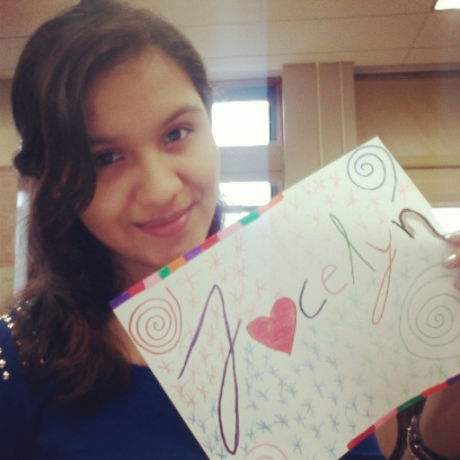

The pictures I chose are mostly centered, colorful, and symbolic. All my pictures were taken in different places, which demonstrates my love for traveling to every single corner of the world. I chose the title “Exciting Journey” because the journey I demonstrate in my pictures is my life. The pictures of my mom, sister and brother symbolize how much they have influenced me in my life. I decided to take a picture of my mom in a school setting because she is like my teacher; she is the one who has guided me all my life, and because of her I am who I am today. My brother’s picture was captured in a moment when he looked at me excited because he had finished his chorus concert. This means a lot to me because I saw him happy for doing what he loves which is singing. The picture of the short and long feet are my sister’s and mine. I am fifteen years older than her and it makes me excited because I feel like I am her second mom. I decided to only show our feet because it symbolizes how both of us will walk side by side in our journey. The man who is giving food to the birds was captured in a moment of kindness. This is what my mom has encouraged me all my life. I decided to make this picture black and white because it intensifies the moment the picture was taken. The place of the picture where the women are dancing is the studio I go to do Zumba. I chose this picture because Zumba has had a major impact in my life, it makes me feel good with myself and I always have fun. The love birds behind the bars represent how complicated love has been for me. Moreover, the hand that is writing on a notebook represents my education and how this is part of my journey in life. Last but not least, the picture with the person walking in the middle of a path represents my journey of life. My final photo is focusing on a clock that is located in Manhattan. I managed to capture the moment where people were passing by the clock and the people created lines, which lead the focus to the clock. I decided to center the clock and use the buildings around it as the frame. It is interesting because a lot of New Yorkers are always rushing and New York itself is all about the busy life. This image froze a moment in time, literally. I did not know anything about photography until I started this intensive. I learned a lot about the elements such as rule of thirds, frame, perspective, patterns and so on. Also I learned that great pictures can be taken by accident. Pictures can capture moments in time that express certain feelings, and these feelings make the viewers revive the moments.

