Review for Regents--
Topic/Time Period | Key Facts, people, events
Ancient River Civilizations
Neolithic Revolution

Belief Systems | Christianity-  Islam-  Hinduism-  Buddhism-  Judaism  Shintoism-
Greece

Rome

Byzantine  Turkey-Russia-  Eastern Part of the Roman Empire- | Key People- Emperor Constantine- stops persecuting then converts to Christianity  Justinian- built on roman law- Justinian’s Code- set of laws posted around empire  Key building- Hagia Sophia Key city- Constantinople  *Western Roman Empire falls- Byzantine (eastern part) survives- flourishes due to location and trade--- Christianity spreads- eventually influences Russian/Eastern Orthodox
Japan | No/few natural resources  Geography- mountains- archipelago- series of islands  Imperialism- forced open to trade- Perry/US-  Feudal Japan- shoguns, samurai- isolationist policy- Tokugawa Shogunate ends---Meiji Restoration- modernize Japan  WWII grabbing up China (Manchuria), violent- Rape of Nanjing, war in Pacific- Kamikaze pilots, Emperor Hirohito, Pearl Harbor, Atomic Bomb dropped to end war on Hiroshima and Nagasaki  Allies rebuild after war – democratic, capitalist model
China

India | Jewel of crown- British Imperialism-
Africa- | Geography-  Egypt-  Mali-  Imperialism- Scramble for Africa- White Man’s Burden- Congress of Berlin-  Kenya-  Sierra Leone-  Rwanda-  South Africa-
Middle Ages/Medieval Europe

Mongols | Genghis Khan- largest contiguous empire- Russia- steppes, nomadic, warriors on horseback, brutal, feared- absorbs bets of conquered culture and spreads  his grandson Kublai Khan/visited by Marco Polo
Renaissance

Reformation- Counter Reformation

Scientific Revolution

Absolute Rule | Absolute Monarchs-Henry VIII/Elizabeth I-England, Peter The Great- Russia, Louis XIV-XVI France  Philipp II, Isabella- Spain complete control over people- build nation
Age of Exploration  1492-1700 | England, France, Portugal, Spain, Dutch East India Co.- Treaty of Tordesillas –Pope divided new/old world  Triangular trade- Columbus- Columbian Exchange- cultural diffusion, Magellan- Circumnavigate- “find” new countries, continents, oceans, conquistadors- “God, Glory, Gold”  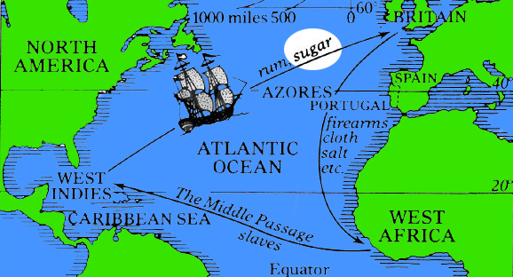
Enlightenment 1600s-1700s | Locke- Natural Rights, Montesquieu, Rousseau, Voltaire,… separation of powers, people/citizens have say/power in gov’t, no torture-- Humanism applied to politics
Age of Revolutions  1776- mid 1800s | Enlightenment inspires Revolution- America 1776, French- 1789- Third Estate-taxes, Guillotine, Robespierre, Louis XVI & Marie Antoinette at Versailles, Haiti- Toussaint L’Ouverture=Black Napoleon…………Simon Bolivar- Latin American 1800s---- independence from colonial owners
Industrial Revolution
Mid 1700s – then again mid 1800s- early 1900s

Imperialism –
late 1800s -WWII

WWI 1914-1919
Russian Revolution 1917

WWII 1939-1945

Cold War

Human Rights | 1948- UN Charter- Declaration of Human rights-all people should have basic rights- shelter, food, water- kids allowed to be kids  1. Irish potato famine- 1845-52- starved 2. Armenian Genocide- 1915 3. Holocaust- 1930s-40s WWII 4. Khmer Rouge- Cambodia- 1970s 5. Apartheid- post WW2- 1990- Mandela pres 1994 6. Bosnia- 1991- ethnic cleansing kill off Muslims 7. Women- bride trafficking, honor killings, 3rd class citizens, genital mutilation- by some extremist groups in M. East, Asia, and Africa 8. Children- sex trafficking – E. Asia, child labor, 1980s- one child policy- female infanticide 9. Rwanda- 1994- Hutu-v. Tutsi -Civil War- genocide 10. Darfur- now- Africa-Sudan- offenders tried for crimes against humanity  Ethnic Cleansing/ Genocide/War Crimes
Environmental
Global Interdependence
Key Isms- | Marxism- Theory of communism- all equal reaction to Ind. Rev- “workers o the world unite”, capitalism(US-Market economy)Adam Smith-law of S&D, Communism(China- Command Economy), Imperialism- Europe grabs up Africa, China, India….good build infrastructure- bad exploit land and people, racism-Need natural resource- materials, and place to sell goods--Mother country makes $, education, hospitals
Other

