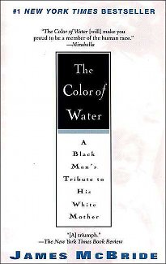
The Color of Water: Assignment Overview

This text is a memoir written by James McBride.
 | NY | MS | ES
DISCERN:  View, read, and listen with focused attention to what matters. |  | Shows a basic understanding of a text(s) | Examines the text closely, making inferences that express a sophisticated understanding of the text
COMMUNICATE:  Make ideas and information understood, mindful of audience, purpose, and setting. |  | Attempts to effectively communicate ideas and conclusions. | Effectively communicates ideas and conclusions.
Not only will we use this text to study narrative non-fiction, but it also will connect to American History and the exploration of James Baldwin’s work that many of you have done in Greg’s class. You will read this text at your own pace with two reading discussion days as deadlines. Some of you may choose to make a schedule for yourselves, others may just prefer to read. You should use this text to help with your narrative non-fiction scrapbook, and as you read consider our essential questions:
- What does personal narrative reveal about a time-period?
- What is narrative non-fiction? And…
- How can we read like a writer?

Schedule:
Blog Post 1: Essential Quotation (Due before discussion day)
Reading Discussion Day 1: Monday, April 29th (First half of book)
COLLABORATE:  Work effectively with others to achieve common goals. |  | Fulfilled agenda tasks and group work and participated without detracting from the group dynamic. | Embraced collaboration as an innovator, improviser and leader of the group.
Blog Post 2: Quotation and discussion question (Due before discussion day-chapters 12 to the end of the text)
Reading Discussion Day 2: Friday, May 10th (Second half of book)

